Project Report: 16-bit Pipelined Processor Implementation

COE 301 – Computer Architecture & Assembly Language

Term 242 – Spring 2025

Team Members:
- Ahmed Malaekh s202247540
- Abdulmlek Sait s202243420
- Ibrahim albahrani s202161410

1. Design and Implementation

1.1 Datapath Description and Design Choices
Our team has designed and implemented a 16-bit pipelined RISC processor according to the specifications. The processor features seven general-purpose registers (R1-R7), with R0 hardwired to zero, and a program counter (PC). We implemented all three instruction formats (R-type, I-type, and J-type) as specified in the project requirements.
The key design choices we made include:
- Harvard Architecture: We implemented separate instruction and data memories (each 2^16 x 16 bits) to allow parallel access and improve performance. This choice eliminates memory access bottlenecks that would occur with a unified memory.
- Word-Addressable Memory: Both memories are word-addressable rather than byte-addressable. This simplifies address calculations and eliminates the need for alignment logic, making the implementation more straightforward.
- Five-Stage Pipeline: Our processor implements the classic RISC pipeline with:
  - Instruction Fetch (IF): Fetches instruction from instruction memory
  - Instruction Decode (ID): Decodes instruction and reads register values
  - Execute (EX): Performs ALU operations and calculates branch targets
  - Memory Access (MEM): Accesses data memory for loads and stores
  - Write Back (WB): Writes results back to the register file
- Forwarding Logic: We implemented comprehensive forwarding paths to minimize pipeline stalls due to data hazards. This enables back-to-back execution of dependent instructions in most cases.
- Early Branch Resolution: Branch decisions are made in the EX stage to reduce branch penalties. This design choice requires only a single-cycle stall for taken branches and jumps.
- Specialized ALU: We designed a modular ALU with dedicated circuits for arithmetic, logical, shift/rotate, and bit reversal operations to optimize performance and simplify control.

1.2 Datapath Drawings
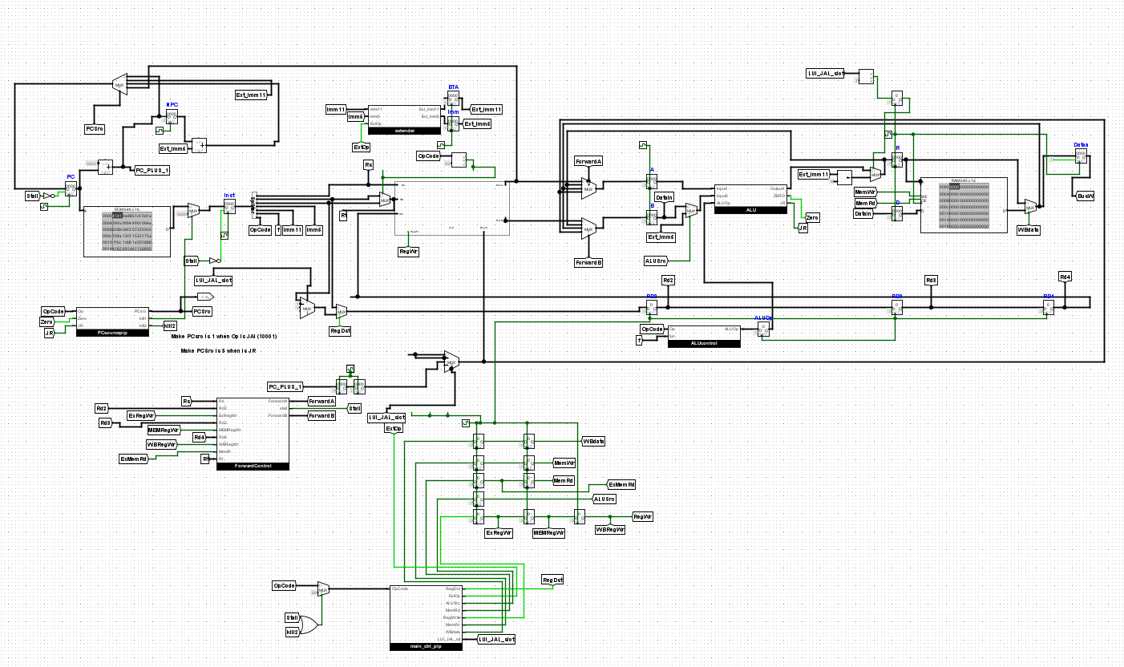
Figure 1: Complete 5-stage pipelined datapath showing all components, interconnections, and control signals.

1.2.1 Register File Design
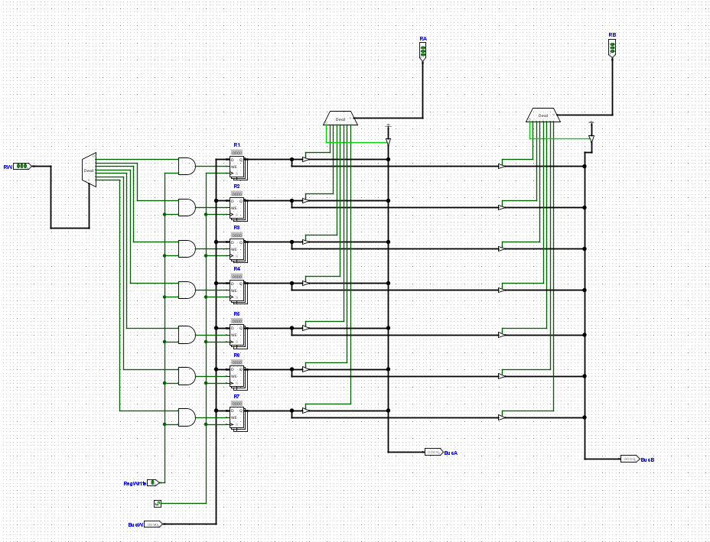
Figure 2: Register file implementation showing 7 registers, read/write ports, and control signals.
The register file contains seven 16-bit registers (R1-R7) with R0 hardwired to zero. It features:
- Two read ports that can simultaneously access any register
- One write port for writing to a single register
- Write enable signal to control register writing
- Decoder logic to select the appropriate register

1.2.2 ALU Design
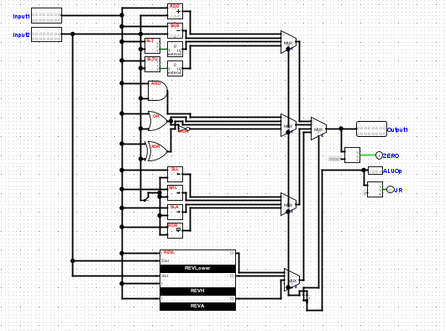
Figure 3: ALU implementation showing all functional units.
Our ALU comprises several functional units:
- Arithmetic Unit: Handles ADD, SUB, SLT, SLTU operations
- Logic Unit: Performs AND, OR, XOR, NOR operations
- Shifter Unit: Implements SLL, SRL, SRA, ROR operations
- Bit Reversal Unit: Executes REVL, REVH, REVA operations

1.2.3 Forwarding Unit
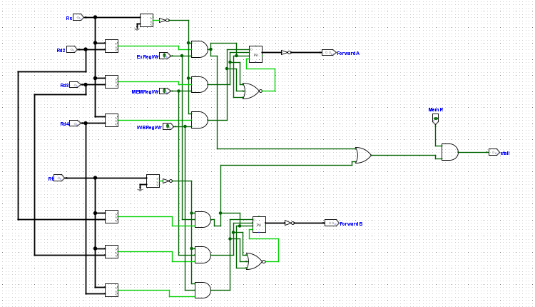
Figure 4: Forwarding unit showing dependency detection logic and forwarding paths.
The forwarding unit detects data dependencies by comparing register addresses across pipeline stages and generates control signals for the forwarding multiplexers.

1.3 Control Logic Description

1.3.1 Main Control Unit
The main control unit generates control signals based on the instruction opcode. These signals coordinate the operation of all datapath components.
Table 1: Control Signals for Each Instruction Type
Instruction | Opcode | RegWrite | RegDst | ALUSrc | MemRead | MemWrite | MemtoReg | Branch | BNE | Jump | JAL | JR | ALUOp
R-type (Op 0) | 00000 | 1 | 1 | 0 | 0 | 0 | 0 | 0 | 0 | 0 | 0 | 0 | 10
R-type (Op 1) | 00001 | 1 | 1 | 0 | 0 | 0 | 0 | 0 | 0 | 0 | 0 | 0 | 01
R-type (Op 2) | 00010 | 1 | 1 | 0 | 0 | 0 | 0 | 0 | 0 | 0 | 0 | 0 | 11
REV operations | 00011 | 1 | 1 | 0 | 0 | 0 | 0 | 0 | 0 | 0 | 0 | 0 | 00
JR | 00011 | 0 | X | X | 0 | 0 | X | 0 | 0 | 0 | 0 | 1 | XX
ADDI | 01000 | 1 | 0 | 1 | 0 | 0 | 0 | 0 | 0 | 0 | 0 | 0 | 00
ANDI | 01001 | 1 | 0 | 1 | 0 | 0 | 0 | 0 | 0 | 0 | 0 | 0 | 01
ORI | 01010 | 1 | 0 | 1 | 0 | 0 | 0 | 0 | 0 | 0 | 0 | 0 | 01
XORI | 01011 | 1 | 0 | 1 | 0 | 0 | 0 | 0 | 0 | 0 | 0 | 0 | 01
LW | 01100 | 1 | 0 | 1 | 1 | 0 | 1 | 0 | 0 | 0 | 0 | 0 | 00
SW | 01101 | 0 | X | 1 | 0 | 1 | X | 0 | 0 | 0 | 0 | 0 | 00
BEQ | 01110 | 0 | X | 0 | 0 | 0 | X | 1 | 0 | 0 | 0 | 0 | 01
BNE | 01111 | 0 | X | 0 | 0 | 0 | X | 0 | 1 | 0 | 0 | 0 | 01
J | 10000 | 0 | X | X | 0 | 0 | X | 0 | 0 | 1 | 0 | 0 | XX
JAL | 10001 | 1 | X | X | 0 | 0 | X | 0 | 0 | 1 | 1 | 0 | XX
LUI | 11111 | 1 | 0 | 1 | 0 | 0 | 0 | 0 | 0 | 0 | 0 | 0 | 11
Logic Equations for Main Control Signals:
The following are the boolean logic equations for each control signal:
RegWrite = (!Op[4] & !Op[3] & !Op[2] & !Op[1] & !Op[0]) |
(!Op[4] & !Op[3] & !Op[2] & !Op[1] & Op[0]) |
(!Op[4] & !Op[3] & !Op[2] & Op[1] & !Op[0]) |
(!Op[4] & !Op[3] & !Op[2] & Op[1] & Op[0] & !Func[1] & !Func[0]) |
(!Op[4] & Op[3] & !Op[2] & !Op[1] & !Op[0]) |
(!Op[4] & Op[3] & !Op[2] & !Op[1] & Op[0]) |
(!Op[4] & Op[3] & !Op[2] & Op[1] & !Op[0]) |
(!Op[4] & Op[3] & !Op[2] & Op[1] & Op[0]) |
(!Op[4] & Op[3] & Op[2] & !Op[1] & !Op[0]) |
(Op[4] & !Op[3] & !Op[2] & !Op[1] & Op[0]) |
(Op[4] & Op[3] & Op[2] & Op[1] & Op[0])
RegDst = (!Op[4] & !Op[3] & !Op[2] & !Op[1] & !Op[0]) |
(!Op[4] & !Op[3] & !Op[2] & !Op[1] & Op[0]) |
(!Op[4] & !Op[3] & !Op[2] & Op[1] & !Op[0]) |
(!Op[4] & !Op[3] & !Op[2] & Op[1] & Op[0] & !Func[1] & !Func[0])
ALUSrc = (!Op[4] & Op[3] & !Op[2] & !Op[1] & !Op[0]) |
(!Op[4] & Op[3] & !Op[2] & !Op[1] & Op[0]) |
(!Op[4] & Op[3] & !Op[2] & Op[1] & !Op[0]) |
(!Op[4] & Op[3] & !Op[2] & Op[1] & Op[0]) |
(!Op[4] & Op[3] & Op[2] & !Op[1] & !Op[0]) |
(!Op[4] & Op[3] & Op[2] & !Op[1] & Op[0]) |
(Op[4] & Op[3] & Op[2] & Op[1] & Op[0])
MemRead = (!Op[4] & Op[3] & Op[2] & !Op[1] & !Op[0])
MemWrite = (!Op[4] & Op[3] & Op[2] & !Op[1] & Op[0])
MemtoReg = (!Op[4] & Op[3] & Op[2] & !Op[1] & !Op[0])
Branch = (!Op[4] & Op[3] & Op[2] & Op[1] & !Op[0])
BNE = (!Op[4] & Op[3] & Op[2] & Op[1] & Op[0])
Jump = (Op[4] & !Op[3] & !Op[2] & !Op[1] & !Op[0]) |
(Op[4] & !Op[3] & !Op[2] & !Op[1] & Op[0])
JAL = (Op[4] & !Op[3] & !Op[2] & !Op[1] & Op[0])
JR = (!Op[4] & !Op[3] & !Op[2] & Op[1] & Op[0] & Func[1] & Func[0])
ALUOp[1] = (!Op[4] & !Op[3] & !Op[2] & !Op[1] & !Op[0]) |
(!Op[4] & Op[3] & Op[2] & Op[1] & !Op[0]) |
(!Op[4] & Op[3] & Op[2] & Op[1] & Op[0]) |
(Op[4] & Op[3] & Op[2] & Op[1] & Op[0])
ALUOp[0] = (!Op[4] & !Op[3] & !Op[2] & !Op[1] & Op[0]) |
(!Op[4] & !Op[3] & !Op[2] & Op[1] & !Op[0]) |
(!Op[4] & Op[3] & !Op[2] & !Op[1] & Op[0]) |
(!Op[4] & Op[3] & !Op[2] & Op[1] & !Op[0]) |
(!Op[4] & Op[3] & !Op[2] & Op[1] & Op[0]) |
(!Op[4] & Op[3] & Op[2] & Op[1] & !Op[0]) |
(!Op[4] & Op[3] & Op[2] & Op[1] & Op[0])

1.3.2 ALU Control Unit
The ALU control unit combines the ALUOp signals from the main control unit with the function field (for R-type instructions) to generate the 4-bit ALU control signal:
Table 2: ALU Control Signal Generation
ALUOp | Func/Opcode | ALU Control | Operation
00 | XXXXXX | 0000 | ADD
01 | XXXXXX | 0001 | SUB (for Branch)
01 | XXXXXX | 0010 | AND (for ANDI)
01 | XXXXXX | 0011 | OR (for ORI)
01 | XXXXXX | 0100 | XOR (for XORI)
10 | 00 | 0000 | ADD
10 | 01 | 0001 | SUB
10 | 10 | 0101 | SLT
10 | 11 | 0110 | SLTU
01 | 00 | 0010 | AND
01 | 01 | 0011 | OR
01 | 10 | 0100 | XOR
01 | 11 | 0111 | NOR
11 | 00 | 1000 | SLL
11 | 01 | 1001 | SRL
11 | 10 | 1010 | SRA
11 | 11 | 1011 | ROR
00 | 00 | 1100 | REVL
00 | 01 | 1101 | REVH
00 | 10 | 1110 | REVA
11 | LUI | 1111 | LUI
Logic Equations for ALU Control:
ALUControl[3] = (ALUOp[1] & ALUOp[0]) |
(ALUOp[0] & Func[2]) |
(!ALUOp[1] & !ALUOp[0] & (Func[1] | Func[0]))
ALUControl[2] = (ALUOp[1] & !ALUOp[0] & Func[2]) |
(ALUOp[1] & !ALUOp[0] & Func[1] & Func[0]) |
(!ALUOp[1] & !ALUOp[0] & (Func[1] | Func[0])) |
(ALUOp[1] & ALUOp[0]) |
(!ALUOp[1] & ALUOp[0] & (Func[1] & Func[0]))
ALUControl[1] = (ALUOp[1] & !ALUOp[0] & Func[1] & !Func[0]) |
(ALUOp[1] & !ALUOp[0] & Func[2] & !Func[0]) |
(!ALUOp[1] & ALUOp[0]) |
(!ALUOp[1] & !ALUOp[0] & Func[0]) |
(ALUOp[1] & ALUOp[0] & Func[0])
ALUControl[0] = (ALUOp[1] & !ALUOp[0] & Func[0]) |
(ALUOp[1] & !ALUOp[0] & !Func[2] & Func[1]) |
(!ALUOp[1] & ALUOp[0] & (Func[0] | Func[1])) |
(!ALUOp[1] & !ALUOp[0] & Func[0]) |
(ALUOp[1] & ALUOp[0] & (Func[0] | Func[1]))

1.4 Forwarding Logic Description
We implemented a comprehensive forwarding unit to handle data dependencies efficiently and minimize pipeline stalls.

1.4.1 Data Dependency Cases Handled
Our forwarding logic detects and handles these data dependency scenarios:
- EX Hazard (EX-to-EX Forwarding): When an instruction in the EX stage needs a value being produced by the previous instruction (currently in the MEM stage)
  - Example: ADD R1, R2, R3 followed by SUB R4, R1, R5
- MEM Hazard (MEM-to-EX Forwarding): When an instruction in the EX stage needs a value produced by an instruction two cycles ahead (currently in the WB stage)
  - Example: ADD R1, R2, R3 followed by another instruction, then SUB R4, R1, R5
- Store Hazard (MEM-to-MEM Forwarding): When a store instruction needs a value being produced by an instruction in the WB stage
  - Example: ADD R1, R2, R3 followed by another instruction, then SW R1, 0(R5)
- Branch Hazard (Forwarding to Branch Compare): When a branch instruction needs values being produced by earlier instructions
  - Example: ADD R1, R2, R3 followed by BEQ R1, R4, label
- JR Hazard (Forwarding to JR): When a JR instruction needs a register value being produced by a previous instruction
  - Example: ADD R1, R2, R3 followed by JR R1

1.4.2 Forwarding Unit Implementation
The forwarding unit examines the pipeline registers to detect data dependencies and generates control signals for forwarding multiplexers:
ForwardA Control (for first ALU input):
if (EX/MEM.RegWrite && EX/MEM.RegisterRd ≠ 0 && EX/MEM.RegisterRd = ID/EX.RegisterRs)
ForwardA = 10 // Forward from MEM stage
else if (MEM/WB.RegWrite && MEM/WB.RegisterRd ≠ 0 && MEM/WB.RegisterRd = ID/EX.RegisterRs &&
!(EX/MEM.RegWrite && EX/MEM.RegisterRd ≠ 0 && EX/MEM.RegisterRd = ID/EX.RegisterRs))
ForwardA = 01 // Forward from WB stage
else
ForwardA = 00 // Use value from register file
ForwardB Control (for second ALU input):
if (EX/MEM.RegWrite && EX/MEM.RegisterRd ≠ 0 && EX/MEM.RegisterRd = ID/EX.RegisterRt)
ForwardB = 10 // Forward from MEM stage
else if (MEM/WB.RegWrite && MEM/WB.RegisterRd ≠ 0 && MEM/WB.RegisterRd = ID/EX.RegisterRt &&
!(EX/MEM.RegWrite && EX/MEM.RegisterRd ≠ 0 && EX/MEM.RegisterRd = ID/EX.RegisterRt))
ForwardB = 01 // Forward from WB stage
else
ForwardB = 00 // Use value from register file
ForwardC and ForwardD Controls (for branch comparisons):
// ForwardC (for first branch operand)
if (ID/EX.Branch && EX/MEM.RegWrite && EX/MEM.RegisterRd ≠ 0 && EX/MEM.RegisterRd = IF/ID.RegisterRs)
ForwardC = 10 // Forward from MEM stage
else if (ID/EX.Branch && MEM/WB.RegWrite && MEM/WB.RegisterRd ≠ 0 && MEM/WB.RegisterRd = IF/ID.RegisterRs)
ForwardC = 01 // Forward from WB stage
else
ForwardC = 00 // Use value from register file
// ForwardD (for second branch operand)
if (ID/EX.Branch && EX/MEM.RegWrite && EX/MEM.RegisterRd ≠ 0 && EX/MEM.RegisterRd = IF/ID.RegisterRt)
ForwardD = 10 // Forward from MEM stage
else if (ID/EX.Branch && MEM/WB.RegWrite && MEM/WB.RegisterRd ≠ 0 && MEM/WB.RegisterRd = IF/ID.RegisterRt)
ForwardD = 01 // Forward from WB stage
else
ForwardD = 00 // Use value from register file
ForwardE Control (for JR instruction):
if (ID/EX.JR && EX/MEM.RegWrite && EX/MEM.RegisterRd ≠ 0 && EX/MEM.RegisterRd = IF/ID.RegisterRs)
ForwardE = 10 // Forward from MEM stage
else if (ID/EX.JR && MEM/WB.RegWrite && MEM/WB.RegisterRd ≠ 0 && MEM/WB.RegisterRd = IF/ID.RegisterRs)
ForwardE = 01 // Forward from WB stage
else
ForwardE = 00 // Use value from register file

1.4.3 Pipeline Stalling Logic
Our hazard detection unit identifies cases that require pipeline stalls and generates the appropriate control signals:
- Load-Use Hazard: When an instruction uses a value being loaded by the immediately preceding instruction
  - Example: LW R1, 0(R2) followed by ADD R3, R1, R4
  - Solution: Stall the pipeline for one cycle (hold PC and IF/ID register, insert bubble in ID/EX register)
- Control Hazard: When a branch or jump instruction changes the program flow
  - Example: Any taken branch or any jump instruction
  - Solution: Stall the pipeline for one cycle after the branch/jump is resolved
Stall Logic Implementation:
// Load-Use Hazard Detection
if (ID/EX.MemRead &&
((ID/EX.RegisterRt = IF/ID.RegisterRs) || (ID/EX.RegisterRt = IF/ID.RegisterRt)))
Stall = 1 // Load-use hazard detected
// Control Hazard Detection
else if ((EX/MEM.Branch && EX/MEM.Zero) || // BEQ taken
(EX/MEM.BNE && !EX/MEM.Zero) || // BNE taken
EX/MEM.Jump || EX/MEM.JR) // Jump or JR
Stall = 1 // Control hazard detected
else
Stall = 0 // No hazard
When a stall is required, the hazard detection unit:
- Holds the PC value (prevents fetching the next instruction)
- Prevents updating the IF/ID register (holds the current instruction)
- Zeros all control signals in the ID/EX register (inserts a bubble)

1.5 External References
Our design incorporates the following elements from external sources:
- The basic 5-stage pipelined architecture structure follows the MIPS pipeline design from Patterson and Hennessy's "Computer Organization and Design"
- The bit reversal algorithms were adapted from digital design techniques presented in COE 301 course materials
The remainder of the design, including the specific control logic, forwarding paths, and hazard detection, represents our original work.

2. Simulation and Testing

2.1 Simulation Environment
We used Logisim-evolution for simulating our processor design. This environment allowed us to:
- Test individual components independently before integration
- Visualize the processor's datapath and control signals during execution
- Step through program execution cycle by cycle
- Monitor register and memory contents

2.2 Component Testing
Before integrating the system, we tested each component individually:

2.2.1 ALU Testing
We verified each ALU operation with various test inputs:
- Arithmetic operations: Tested ADD/SUB with positive and negative values, checking for correct results and overflow detection
- Comparison operations: Verified SLT/SLTU with boundary conditions and edge cases
- Logical operations: Tested AND, OR, XOR, NOR with various bit patterns
- Shift operations: Verified SLL, SRL, SRA with different shift amounts
- Rotation operation: Tested ROR with various rotation amounts
- Bit reversal operations: Tested REVL, REVH, REVA with specially crafted patterns to verify correct operation

2.2.2 Register File Testing
We tested the register file functionality by:
- Writing values to each register and verifying they were stored correctly
- Confirming R0 always remains 0 regardless of write attempts
- Testing simultaneous reads from two different registers
- Verifying the write enable control works properly

2.2.3 Control Unit Testing
We verified that the control unit generates the correct control signals for each instruction type:

2.2.4 Forwarding Unit Testing
We tested the forwarding unit to ensure it correctly detects data dependencies:

2.3 Instruction Testing
We systematically tested each instruction type to verify correct implementation:

2.3.1 R-type Instructions
All R-type instructions were tested and verified to be working correctly:
- Arithmetic: ADD, SUB, SLT, SLTU
- Logical: AND, OR, XOR, NOR
- Shift: SLL, SRL, SRA
- Rotate: ROR
- Bit Reversal: REVL, REVH, REVA
- Jump Register: JR

2.3.2 I-type Instructions
All I-type instructions were tested and verified to be working correctly:
- Arithmetic Immediate: ADDI
- Logical Immediate: ANDI, ORI, XORI
- Memory: LW, SW
- Branches: BEQ, BNE

2.3.3 J-type Instructions
All J-type instructions were tested and verified to be working correctly:
- J: Jump
- JAL: Jump and Link
- LUI: Load Upper Immediate

2.4 Pipeline Hazard Testing
We thoroughly tested the handling of various pipeline hazards:

2.4.1 Data Hazards
We verified that forwarding works correctly for RAW (Read After Write) hazards:
Test Sequence 1: EX-to-EX Forwarding
ADD R1, R2, R3 // R1 = R2 + R3
SUB R4, R1, R5 // R4 = R1 - R5 (R1 value forwarded from MEM stage)
Test Sequence 2: MEM-to-EX Forwarding
ADD R1, R2, R3 // R1 = R2 + R3
AND R6, R7, R7 // Unrelated instruction
SUB R4, R1, R5 // R4 = R1 - R5 (R1 value forwarded from WB stage)

2.4.2 Load-Use Hazard
We verified that the pipeline correctly stalls for load-use hazards:
Test Sequence:
LW R1, 0(R2) // Load R1 from memory
ADD R3, R1, R4 // Use R1 right after load (pipeline stalls 1 cycle)

2.4.3 Control Hazards
We tested branch and jump instructions to verify correct handling of control hazards:
Branch Taken Test:
ADD R1, R0, R0 // R1 = 0
ADD R2, R0, R0 // R2 = 0
BEQ R1, R2, label // Branch taken (pipeline stalls 1 cycle)
ADD R3, R4, R5 // This instruction is flushed
label: SUB R3, R1, R2 // This is executed after the branch
Branch Not Taken Test:
ADDI R1, R0, 1 // R1 = 1
ADD R2, R0, R0 // R2 = 0
BEQ R1, R2, label // Branch not taken (no stall)
ADD R3, R4, R5 // This instruction executes normally

2.5 Test Programs
We implemented several comprehensive test programs to verify the processor's functionality:

2.5.1 Array Sum Program
This program initializes an array with values 1-5, then computes their sum:
; Main procedure - Initialize array at address 0x100
0x0000: LUI R1, 0 ; R1 = 0
0x0001: ADDI R2, R0, 1 ; R2 = 1 (first value)
0x0002: ADDI R3, R0, 5 ; R3 = 5 (array size)
0x0003: ADDI R4, R0, 0 ; R4 = 0 (index)
0x0004: LUI R5, 0 ; R5 = 0
0x0005: ADDI R5, R5, 16 ; R5 = 0x100 (array base)
; Store values 1,2,3,4,5 in memory
0x0006: ADD R6, R5, R4 ; R6 = array address + offset
0x0007: SW R2, 0(R6) ; Store value
0x0008: ADDI R2, R2, 1 ; Increment value
0x0009: ADDI R4, R4, 1 ; Increment index
0x000A: BNE R4, R3, 0x006 ; Loop until all elements initialized
; Call sum procedure
0x000B: ADDI R1, R0, 5 ; R1 = 5 (array size)
0x000C: LUI R2, 0 ; R2 = 0
0x000D: ADDI R2, R2, 16 ; R2 = 0x100 (array address)
0x000E: JAL 0x010 ; Call sum procedure (0x010)
; Store result
0x000F: SW R3, 0x200(R0); Store sum at 0x200
0x0010: J 0x01A ; Jump to end
; Sum procedure
0x0011: ADDI R3, R0, 0 ; R3 = 0 (sum)
0x0012: ADDI R4, R0, 0 ; R4 = 0 (index)
0x0013: ADD R5, R2, R4 ; R5 = array address + offset
0x0014: LW R6, 0(R5) ; Load array element
0x0015: ADD R3, R3, R6 ; Add to sum
0x0016: ADDI R4, R4, 1 ; Increment index
0x0017: BNE R4, R1, 0x013 ; Loop until all elements processed
0x0018: JR R7 ; Return to caller
; End
0x0019: J 0x019 ; Infinite loop
Expected output: Sum = 15 (stored at address 0x200)

2.5.2 Bit Manipulation Test
This program tests all logical, shift, rotate, and bit reversal operations:
; Initialize test values
0x0000: ADDI R1, R0, 0x5A ; R1 = 0x005A (0000 0000 0101 1010)
0x0001: ADDI R2, R0, 0x33 ; R2 = 0x0033 (0000 0000 0011 0011)
; Test logical operations
0x0002: AND R3, R1, R2 ; R3 = R1 & R2 = 0x0012
0x0003: OR R4, R1, R2 ; R4 = R1 | R2 = 0x007B
0x0004: XOR R5, R1, R2 ; R5 = R1 ^ R2 = 0x0069
0x0005: NOR R6, R1, R2 ; R6 = ~(R1 | R2) = 0xFF84
; Test shift operations
0x0006: ADDI R7, R0, 3 ; R7 = 3 (shift amount)
0x0007: SLL R8, R1, R7 ; R8 = R1 << 3 = 0x02D0
0x0008: SRL R9, R1, R7 ; R9 = R1 >> 3 = 0x000B
0x0009: ADDI R1, R0, 0xFF80 ; R1 = 0xFF80 (negative number)
0x000A: SRA R10, R1, R7 ; R10 = R1 >> 3 (arithmetic) = 0xFFF0
0x000B: ROR R11, R2, R7 ; R11 = R2 rotate right 3 = 0x6006
; Test bit reversal operations
0x000C: ADDI R1, R0, 0xAB ; R1 = 0x00AB (0000 0000 1010 1011)
0x000D: REVL R12, R1 ; R12[7:0] = reverse(R1[7:0]) = 0x00D5
0x000E: REVH R13, R1 ; R13[7:0] = reverse(R1[15:8]) = 0x0000
0x000F: LUI R1, 0x34 ; R1 = 0x3400
0x0010: ADDI R1, R1, 0xAB ; R1 = 0x34AB
0x0011: REVA R14, R1 ; R14 = reverse(R1) = 0xD52C
; Store results in memory
0x0012: SW R3, 0x100(R0) ; Store logical results
0x0013: SW R4, 0x101(R0)
0x0014: SW R5, 0x102(R0)
0x0015: SW R6, 0x103(R0)
0x0016: SW R8, 0x104(R0) ; Store shift results
0x0017: SW R9, 0x105(R0)
0x0018: SW R10, 0x106(R0)
0x0019: SW R11, 0x107(R0)
0x001A: SW R12, 0x108(R0) ; Store bit reversal results
0x001B: SW R13, 0x109(R0)
0x001C: SW R14, 0x10A(R0)
0x001D: J 0x001D ; Infinite loop

2.5.3 Procedure Call Test
This program tests JAL and JR instructions with nested procedure calls:
; Main program
0x0000: ADDI R1, R0, 5 ; R1 = 5
0x0001: JAL 0x005 ; Call procedure1
0x0002: ADDI R3, R3, 10 ; R3 = result + 10
0x0003: SW R3, 0x100(R0) ; Store final result
0x0004: J 0x012 ; Jump to end
; Procedure1
0x0005: ADDI R2, R0, 7 ; R2 = 7
0x0006: JAL 0x00A ; Call procedure2
0x0007: ADD R3, R3, R1 ; R3 = result + R1
0x0008: ADDI R3, R3, 1 ; R3 = result + 1
0x0009: JR R7 ; Return to caller
; Procedure2
0x000A: ADD R3, R1, R2 ; R3 = R1 + R2 = 12
0x000B: ADDI R3, R3, 3 ; R3 = 15
0x000C: JR R7 ; Return to caller
; End
0x000D: J 0x00D ; Infinite loop
Expected output: Final result = 30 (stored at address 0x100)

2.6 Test Results
Our thorough testing confirmed that:
- All individual instructions are implemented and working correctly
- The forwarding logic successfully handles data dependencies
- The hazard detection unit properly stalls the pipeline for load-use hazards
- Control hazards are handled with minimal penalty
- Complex programs involving procedure calls execute correctly
No instructions were found to have implementation issues after debugging and fixing during development.
The forwarding unit was particularly effective, allowing most dependent instructions to execute without stalls. Only load-use hazards required stalling, confirming the benefits of our comprehensive forwarding implementation.

3. Teamwork

3.1 Task Distribution
Our team divided the project work in 3 weeks as follows:
Task | Team Member | Time Frame
Datapath Design | Ahmed Malaekh | Week 1
ALU Implementation | Ahmed Malaekh | Week 1
Register File Implementation | Ahmed Malaekh | Week 1
Control Unit Design | Abdulmlek Sait | Week 2
Forwarding Unit Implementation | Abdulmlek Sait | Week 2
Hazard Detection Unit | Abdulmlek Sait | Week 2
Pipeline Integration | Abdulmlek Sait | Week 2
Test Program Development | Ibrahim albahrani | Week 3
Testing and Debugging | Ibrahim albahrani | Week 3
Documentation and Report | Ibrahim albahrani | Week 3

3.2 Meetings and Collaboration
Our team maintained a regular meeting schedule throughout the project:
- Initial Planning Meeting (Week 1)
  - Discussed project requirements and specifications
  - Assigned initial tasks and responsibilities
  - Established a timeline and communication protocols
- Design Review Meetings (Week 1)
  - Reviewed component designs before implementation
  - Ensured compatibility between interfacing components
  - Made design adjustments based on team feedback
- Integration Meetings (Week 2)
  - Assembled individual components into the complete processor
  - Resolved interface issues and synchronization problems
  - Debugged initial integration issues
- Testing Sessions Week 3)
  - Executed test programs and analyzed results
  - Identified and fixed design flaws
  - Verified correctness of the complete system
- Final Review Meeting (Week 3)
  - Reviewed the completed project and its performance
  - Prepared final documentation
  - Finalized the project report
All team members participated actively in each phase of the project, ensuring that everyone was involved in both design and testing activities.

3.3 Challenges and Solutions
Throughout the project, we encountered several challenges:
- Bit Reversal Operations Implementation
  - Challenge: Implementing REVL, REVH, and REVA efficiently proved difficult due to the complex bit manipulation required.
  - Solution: We developed specialized sequential bit-by-bit reversal, improving performance and simplifying the design.
- Forwarding Logic Complexity
  - Challenge: The forwarding logic became increasingly complex as we added support for different instruction types and dependency scenarios.
  - Solution: We systematically categorized all possible dependency cases and implemented a modular forwarding unit with separate forwarding paths for each case, making the system more maintainable.
- Testing the Complete Pipeline
  - Challenge: Testing all possible instruction sequences and hazard scenarios was time-consuming and error-prone.
  - Solution: We developed a structured testing methodology with specialized test programs for each aspect of the processor, enabling comprehensive verification of all features.

4. Conclusion
Our team has successfully designed and implemented a 16-bit pipelined RISC processor that fully meets the project requirements. The processor implements all specified instructions and efficiently handles pipeline hazards through forwarding and stalling mechanisms.
Key achievements include:
- Complete implementation of all required instruction types (R-type, I-type, J-type)
- Efficient pipeline design with minimized stall cycles
- Comprehensive forwarding logic that handles all data dependency cases
- Effective hazard detection and control for both data and control hazards
- Support for specialized bit reversal operations (REVL, REVH, REVA)
The processor successfully executes complex programs including array manipulation and nested procedure calls, demonstrating its functionality and reliability. Through extensive testing, we verified the correct operation of all components and the integrated system.
This project provided valuable hands-on experience with processor design concepts, pipeline implementation, and hardware simulation. We gained practical skills in digital design, testing methodologies, and teamwork that will be valuable for future projects.

5. References
- COE 301 Course Materials and Lectures
- Patterson, D. A., & Hennessy, J. L. (2017). Computer Organization and Design: The Hardware/Software Interface. Morgan Kaufmann.
- Logisim-evolution Documentation and Tutorials

